Attending Polar2018 was a really enriching experience for many reasons. It was the first international conference I had attended. In fact, it was my very first conference, and I was amazed. Firstly, I was able to listen to the scientists doing leading-edge research on polar topics. I was surrounded by the most expert people on polar science, and, what was even more encouraging, I met people who were beginning what would be a brilliant scientific career on polar science.
Seeing many ECRs giving great talks inspired and encourage me to present one myself in coming conferences. One of the greatest opportunities Polar2018 offered me was to present for the first time my research in a conference. I presented a poster on my first work as a polar researcher in training. I could explain my work to several people who got interested in it, and I made contacts to some of them for future sharing of our work. Also, the conference was a perfect opportunity to meet, most of them in person for the first time, with my colleagues from APECS Spain, to discuss the guidelines for the re-activation of this organization. Moreover, I could meet and establish a link to members from many other APECS national committees.
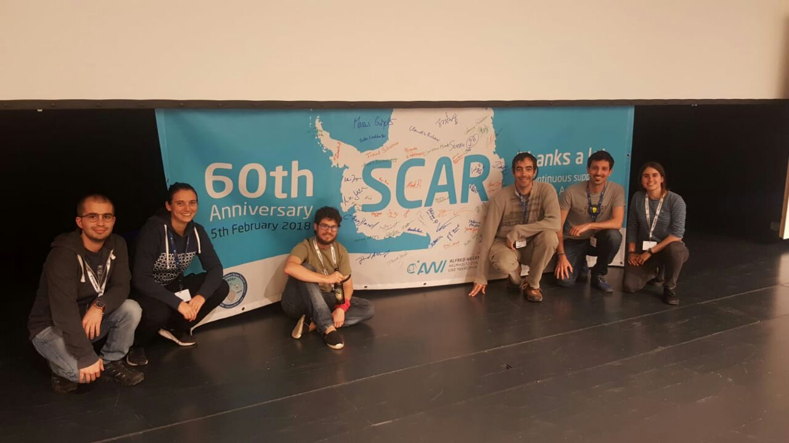
The wide number of talks allowed me to attend many related to my topics of research. I made the most of these taking notes of ideas, experimental design, or results. Also, as an ECR working in Antarctica, I really appreciated getting a multidisciplinary view of this continent, which helped me contextualize the work of our team. Finally, I found brilliant the highlighting of social matters during the OSC, such as the view of Arctic indigenous people, and women and the LGBTQ+ community in polar science.

