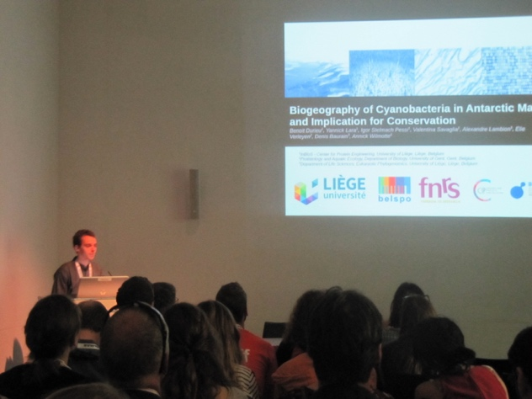
Report on Polar2018: "Expedition in the third pole”
On the morning of the 15 June 2018, my colleague and me met at the train station, with luggage, food, water and poster tubes. After more than 10 hours of travel, 4 trains, beautiful landscapes, we arrived at destination: the third pole! Indeed, this year, SCAR and IASC joined their Open Science Conference in the Alps, Davos, Switzerland, under the banner “Polar2018: Where the Poles come together”.
After a very interesting side workshop about data management and next generation analyses, I started the conference with a lot of stress since I had a talk on the first day, in the first session! But it went well, I had great exchange of ideas, and I could finally be able to enjoy the other sessions, without stress!
To enjoy is the right term: the subjects were well grouped, I was able to attend to talks that were very close to my field and to other a little bit more distant, but all of them were very interesting and helped me to contextualize my work. During these days I met wonderful people, some stars I always read about, but also young budding stars with strong motivation and amazing ideas!
I came back to Belgium with new inspiration for my research and very nice memories!"

